**Anocat – User guide**

1. Anomaly detection – Input Day, month and year from the drop down and hit submit button to see the anomaly figure.

2. Visualization – This page will give word cloud visualizations according to L1 and L2 tags. Select L1 tag from drop down and hit submit to see word cloud associated with L1 tag and follow the same steps to see word cloud for L2 tags.

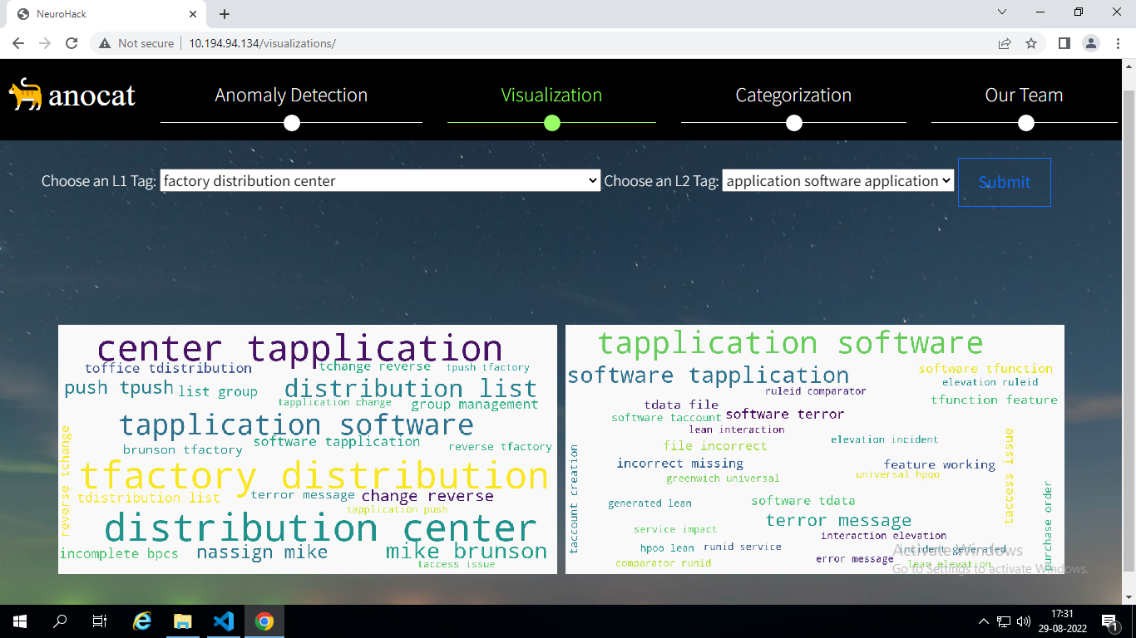

3.Categorization – This page will show Tree map of predicted L1 and L2 tags from our model. Also, after scrolling, you will find a form to upload ticket dump to see the predicted tags once you submit the .csv file.

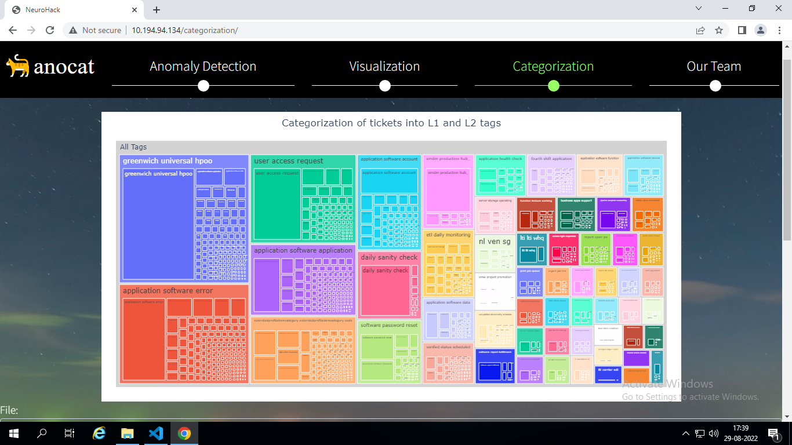

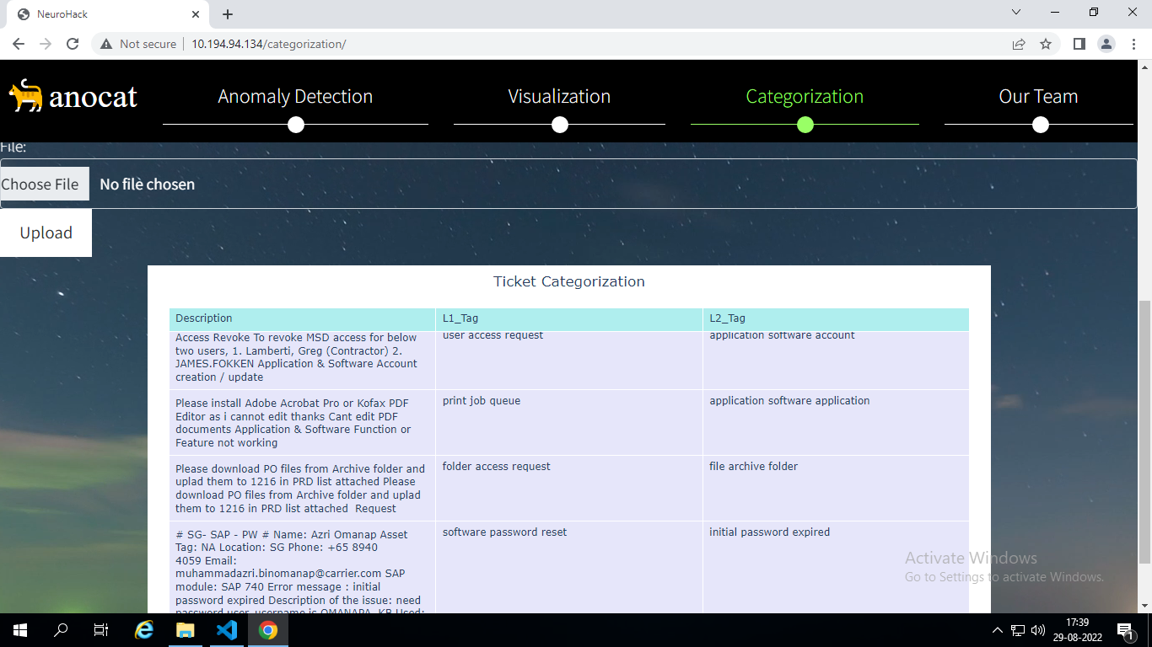

4. Our team – The final page will showcase our team and you will find all the documentations here.

